Getting Started with the NDK
The Native Development Kit (NDK) is a set of tools that allows you to use C and C++ code with Android, and provides platform libraries you can use to manage native activities and access physical device components, such as sensors and touch input. The NDK may not be appropriate for most novice Android programmers who need to use only Java code and framework APIs to develop their apps. However, the NDK can be useful for cases in which you need to do one or more of the following:
- Squeeze extra performance out of a device to achieve low latency or run computationally intensive applications, such as games or physics simulations.
- Reuse your own or other developers' C or C++ libraries.
Using Android Studio 2.2 and higher, you can use the NDK to compile C and C++ code into a native library and package it into your APK using Gradle, the IDE's integrated build system. Your Java code can then call functions in your native library through the Java Native Interface (JNI) framework. To learn more about Gradle and the Android build system, read Configure Your Build.
Android Studio's default build tool to compile native libraries is CMake. Android Studio also supports ndk-build due to the large number of existing projects that use the build toolkit. However, if you are creating a new native library, you should use CMake.
This guide gives you the information you need to get up and running with the NDK on Android Studio. If you don't have the latest version of Android Studio, download and install it now.
Attention experimental Gradle users: Consider migrating to plugin version 2.2.0 or higher, and using CMake or ndk-build to build your native libraries if any of the following apply to you: Your native project already uses CMake or ndk-build; you would rather use a stable version of the Gradle build system; or you want support for add-on tools, such as CCache. Otherwise, you can continue to use the experimental version of Gradle and the Android plugin.

Download the NDK and Tools
To compile and debug native code for your app, you need the following components:
- The Android Native Development Kit (NDK): a set of tools that allows you to use C and C++ code with Android.
- CMake: an external build tool that works alongside Gradle to build your native library. You do not need this component if you only plan to use ndk-build.
- LLDB: the debugger Android Studio uses to debug native code.
You can install these components using the SDK Manager:
- From an open project, select Tools > Android > SDK Manager from the main menu.
- Click the SDK Tools tab.
- Check the boxes next to LLDB, CMake, and NDK, as shown in figure 1. 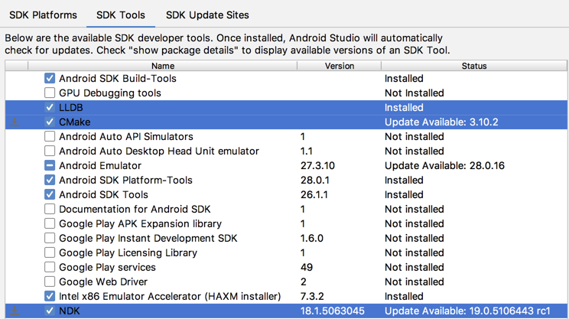
Figure 1. Installing LLDB, CMake, and the NDK from the SDK Manager.
- Click Apply, and then click OK in the next dialog.
- When the installation is complete, click Finish, and then click OK.

Create or Import a Native Project
Once you set up Android Studio, you can simply Create a New Project with C/C++ Support. However, if you want to add or import native code to an existing Android Studio project, you need to follow this basic process:
- Create new native source files and add them to your Android Studio project.
  - You can skip this step if you already have native code or want to import a prebuilt native library.
- Create a CMake build script to tell CMake how to build your native sources into a library. You also require this build script if you are importing and linking against prebuilt or platform libraries.
  - You can skip this step if your existing native library already has a CMakeLists.txt build script, or uses ndk-build and includes an Android.mk build script.
- Link Gradle to your native library by providing a path to your CMake or ndk-build script file. Gradle uses the build script to import source code into your Android Studio project and package your native library (the SO file) into the APK.
Note: If your existing project uses the deprecated ndkCompile tool, you should open your build.properties file and remove the following line of code before configuring Gradle to use CMake or ndk-build:
// Remove this line
android.useDeprecatedNdk = true
- Build and run your app by clicking Run . Gradle adds your CMake or ndk-build process as a dependency to compile, build, and package your native library with your APK.
Once your app is running on a physical device or the emulator, you can use Android Studio to Debug Your App. Otherwise, to learn more about the NDK and its components, read the Concepts page.

